|  |
| --- |
|  |



**8 February 2013** **The Weekly Bulletin of Rotary Club of Kathmandu Mid-Town** **Bc-8.2/012-13**

**District : 3292 Web: www.rotarymidtown.org.np Club Id : 26776**

**FEBRUARY IS WORLD UNDERSTANDING MONTH**

Advancing world understanding and peace, which is expressed in the fourth part of the Object of Rotary, is an important focus of Rotarian service. It is the impetus for numerous service efforts and other cooperative ventures among Rotarians from different parts of the world. It is the reason Rotary International has a long-standing, close collaboration with the United Nations and many of its member agencies. Appropriately, every year the anniversary of the founding of Rotary, 23 February, is celebrated as World Understanding and Peace Day.

Friday, 25 January:

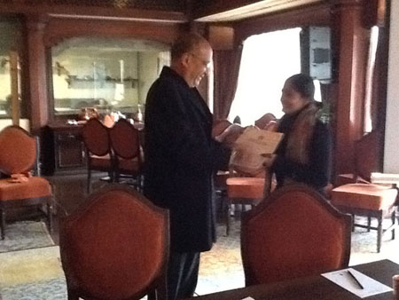

Guest Speaker Ms Radha Poudel, Founder of and Managing

Director in Action Works Nepal, talked on how she took a 'U' turn

on her profession from government employee (nurse) to social

worker. She presented a brief video clip showing her works/

project activities her organization has been doing with a view of

helping women for social upliftment in Karnali zone, her focus

area. In the picture, VP Govind Chipalu, officiating President,

handing over a certificate of appreciation to Guest Speaker Radha.

Friday, 1 February:

Ms Rajju Malla Dhakal, Guest Speaker, provided a very interesting account of gender issues, gender equality, male dominated society, cultural impact on gender bias, need for ddressing the issues at grass-root level etc.

# Weekly Meetings and Programs :

|  |  |  |
| --- | --- | --- |
| Date | Program/Speaker | Program/Topics of Presentation |
| 1 Feb 2013 | Rajju Malla Dhakal | Gender equality and issues |
| 8 Feb 2013 | ??? |  |

Friday, 8 February:

???

**Bishnumati River Re-habilation Project:**

**Dear Club Presidents, Club Secretaries and Rotarians:**

***Greetings***

You may be aware that out of the many focus areas of Rotary in it's movement for World Understanding and Peace through selfless yet meaningful service projects; one of them has been of them is on ***Economic and Community Development*** (which looks at Urban Concern areas). In this same light the  **The River Bishnumati  Rehabilitation Project**, is an effort on the part of Common Concern Nepal (CCN) with Rotary International District 3292-Nepal, in taking the lead in coming up with a much needed sustainable awareness campaign covering the River Bishnumati corridor, through an effective coordinated & integrated TEAM work approach of all the genuinely interested parties. This will be part of the KVDA & KMC Master Plan project for the improvement of the river system in the Kathmandu Valley, in  which the local Community will be encouraged to play an effective role, displaying their sense of pride and ownership on this ambitious Bishnumati river Re-habilitation project, code named, "Mission Impossible". The project will cover the 18 km. River Bishnumati  corridor, divided into 10 Sectors, each with a Bridge as a focal / control point, starting from its source, at Shivapuri, to its confluence with the River Bagmati, at "Teku Doban". Infact the project will also look to explore the other focus areas too, viz. disease prevention (and treatment) and (basic) education (and literacy).

The project is designed to be implemented in TWO phases:

Phase 1 will be through a PPP (private public participation / people’s participation) program, to be carried out in the 10 Sectors of the Bishnumati corridor, with Budhanilkantha Bridge area as Sector 1, as the model to be followed in the other Sectors.  The sustainable part of the program  will be the responsibility of the local Community in their respective Sectors, supported by an NGO funding program on the Environment Awareness on the prevention of the river degradation.

Phase 2 will be a national level project, under German Advisory Team, Prof. Dr. Radermacher of Germany. With Rotary International District 3292 / CCN, providing the leadership, it will form part of the KVDA & KMC Master plan for the improvement of The River system of the Kathmandu Valley covering the River Bishnumati portion, with input / participation of the concerned Government Departments involved. This is at present in its preliminary stage of planning.

As a start to the program;  a river cleaning campaign on 22 Dec. 2012, was to get all the stakeholders of the community of Budhanilkantha Bridge area (Sector 1), to show their concern about the need to contain the gravity of the degradation of the river environment,  by coming out in force to make this campaign a success.  This will be followed Sector wise, by targeting the community at each of the bridge location /school , during every last Saturday of the month respectively, till the entire River Bishnumati corridor of 10 Sectors has been covered by the years end.

Now, on **Saturday the 2nd February (20th Magh) from 11am**the cleaning up campaign is being organized under the Phase 1, Sector 2, at Main Bus Stop bridge in GONGABU, Kathmandu. Participants expected are from the  Local Youth , women organization, NGOs, Schools, Army presence (200 ), APF & Police and Rotarians; including the local Community.

Therefore now, the organizers also humbly request the participation of Rotarians to the campaign which is a noble effort. Your presence (even for a short time) will indeed encourage all those who are working towards the success of the project. Kindly find time and show your support.

Thank you for your kind attention.

With Kind Regards

Rajesh Thapa

Member Steering Committee Representing RID 3292

*Courtesy: PP Pratap Malla*

Rotarians, community leaders, police and army personnel on the job of cleaning

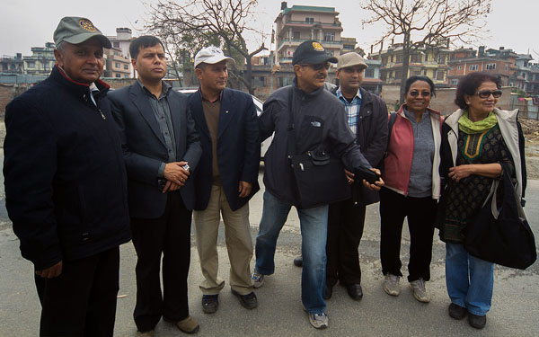 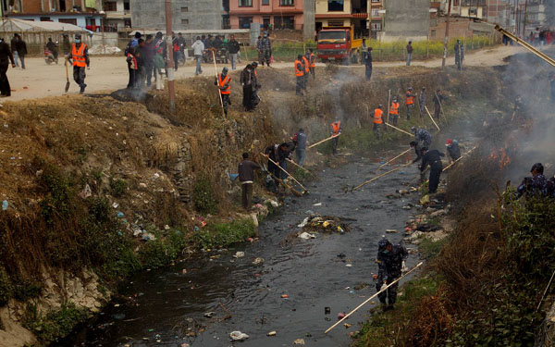

Bishnumati River On Saturday, 2 Feb 2013

*Source: Rtn Navyo Eller*

**RLI Training – Message from the Chair, RLI Nepal Division :**

RLI Nepal Division is organizing RLI training Part I, II and III, a three days graduate course  in Kathmandu from February 8, 9 & 10, 2013, Participants can have either Part 1 only or part II & III, but participants who want to join in part II and III must have completed Part I. The Rotarians completing the Graduate Course are awarded with a Certificate and a special RLI Pin.

The Rotary Leadership Institute (RLI) is a joint venture of Rotary Clubs all over the world offering training programs to Rotarians by developing unique technique of presentation and assisting in improving the Rotary knowledge and leadership skills among the Rotarians. It is hoped that the education and training provided by the RLI will motivate the participants to be enthusiastic, creative and dedicated Rotarians.

Rotarians requiring any assistance may contact PP Prafulla Man Pradhan at Mobile # 9851088522 email: [pradhan.prafulla@gmail.com](mailto:pradhan.prafulla@gmail.com).  As there will be limited seats timely information of participation to Rtn. Prafulla Man will be appreciated.

*courtesy: Rtn Buddha Laishram, Club Secretary*

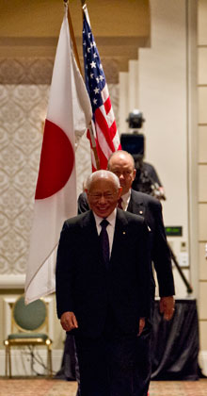

Service Above Self reminds us that none of us can live for ourselves alone. A life lived in

isolation is empty and without joy. But when we live for others — when we focus on our role

within our family, our community, and all humanity — then we begin to realize our own place

in the world.

**RI President Sakuji Tanaka**

**Committee Chairpersons' Column:**

**???**

**Past Presidents' Column:**

**???**

On Lighter Side :

Click here ⇩



A thought for the day:

**Never play with the feelings of others, because you may win the game**

**but the risk is that you will surely lose the person for life time.**

Great quotes:

***SILENCE is the best answer for all questions;***

***SMILE is the best reaction in all situations !***

Number game:

If a2 = b2+c2; b2 = (a + c)(a - c); c2 = a + b; and a + b + c = 12

find the value of a, b, and c.

Last week's puzzle solution: What comes next in the series: 3, 7, 16, 35, …. ? (74)

NB: Send any informations/photos that may be of interest to the Club or Rotarians in general to

BC Editor: RR Shrestha email: rryesrr@gmail.com

## 8 Feb 2013 The Weekly Bulletin of Rotary Club of Kathmandu Mid-Town bc-8.2/012-13